B+ trees:

MCQs:

Q: In a B+ Tree, where are the actual records (data pointers) stored?
a) In internal nodes only
b) In leaf nodes only
c) In both internal and leaf nodes
d) In the root node only
Answer: B

What is the maximum number of keys a B+ Tree of order m can have in a single node?
a) m - 1
b) m
c) 2m
d) 2m – 1

Answer: A

The time complexity of search, insert, and delete operations in a B+ Tree with n keys is:
a) O(1)
b) O(log n)
c) O(n)
d) O(n log n)

Answer: B

When inserting into a B+ Tree, if a leaf node overflows, what typically happens?
a) The tree is rebuilt from scratch
b) The node is split and the middle key is promoted to the parent
c) The entire level is restructured
d) The overflow is ignored

Answer: B

In a B+ Tree of order m, what is the maximum number of children an internal node can have?
a) m
b) m - 1
c) 2m
d) 2m – 1
Answer: A

If a B+ Tree has height h and stores n keys, what is the worst-case time complexity of searching for a key?
a) O(1)
b) O(log n)
c) O(h)
d) O(n)
Answer: B
Which of the following best describes the height h of a B+ Tree with n keys and order m?
a) h = O(n)
b) h = O(log n) with base m
c) h = O(logm n)
d) h = O(log2 n)
Answer: C
During deletion from a B+ Tree, if a leaf node has fewer than the minimum number of keys:
a) The tree is rebuilt from scratch
b) Keys are borrowed from a sibling or nodes are merged
c) The underflow is ignored
d) The root is deleted automatically
Answer: B
Suppose a B+ Tree of order m has n keys. What is the maximum possible number of leaf nodes?
a) n
b) n/m
c) n/(m - 1)
d) log_m(n)
Answer: C
Which of the following operations might cause merging of nodes in a B+ Tree?
a) Search
b) Insert
c) Delete
d) Range Query
Answer: C

In a B+ Tree of order m, the maximum number of keys in an internal node is:
a) m
b) m - 1
c) 2m
d) 2m – 1
Answer: B
In a B+ Tree of order m, the minimum number of keys in a non-root internal node is:
a) ⌈m/2⌉ - 1
b) ⌊m/2⌋
c) m/2
d) ⌈m/2⌉
Answer: A
If the order of a B+ Tree is doubled, how does the height change approximately (for large n)?
a) It doubles
b) It halves
c) It remains unchanged
d) It increases slightly but not doubled
Answer: B (More keys fit in each node -> fewer levels needed -> height decreases, roughly by half)

Short Questions:
Given a max degree of 5, construct a B+ after the following operations in order:
Insert([7, 10, 1, 23, 5, 15, 17, 9, 11, 39, 35, 8, 40, 25])
Answer:
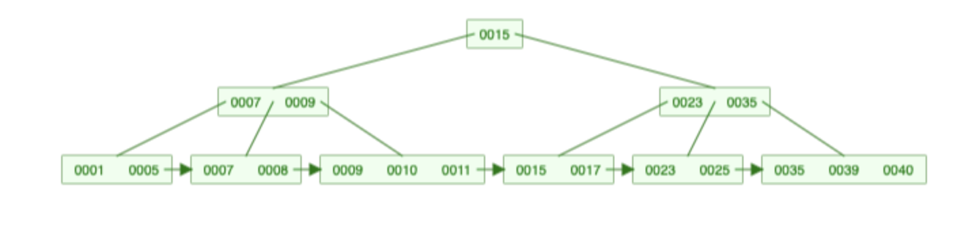

Delete(9)
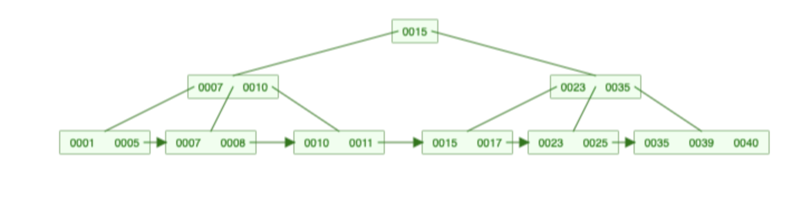

Delete(7)

